


Committee on Committees Minutes

Associated Students
DATE: May 20, 2026
LOCATION: AS Main CoC Room Minutes/Actions recorded by: Vice Chair

CALL TO ORDER: 5:00PM by Lily, Internal Chair

QOTW: What is one thing about CoC new board members should know?

A. MEETING BUSINESS

- Roll Call

Name | Note:  absent (excused/not excused)  arrived late (time)  departed early (time)  proxy (full name) | Name | Note:  absent (excused/not excused)  arrived late (time)  departed early (time)  proxy (full name)
Lily Strange | Present | Savanah Lizet Aldaba | Present
Shuyi Sum | Present | Adam Orenstein | ...
Oliver Ramirez Carrera | Present | Archish Prakhya | ...
Layla Hakim | Present
Mira Ikladious | Present

- Acceptance of Excused Absences

MOTION/SECOND: Last Name/Last Name
Motion Language: SAMPLE MOTION LANGUAGE
ACTION: Consent

- Acceptance of Proxies

B. PUBLIC FORUM

- EXTERNAL REPORTS

- Advisor’s Report

- Executive Officer’s Report(s)

- Group Project/Member Report(s)
  - Advisor and Senate Liaison Reports

Lily Strange - Internal Chair
    - QOTW: never leave chairs meeting supplies in the CoC room….
    - Welcome new members!! + introductions
      - Some quick onboarding tasks:
        - Fill out your contact on this sheet
        - Get in touch for passdown reports!
          - Shuyi + Oliver
          - Oliver + Kristin
          - Lily + Thomas
        - Email log ins + recovery number transfers
          - I submitted an AS help ticket to get separate O&R emails!
            - Each of you should get an email soon to set that up, please add the new email + password to your passdown when you get it
            - We are down one O&R so I gave Oliver’s contact for the 4th O&R email
        - I will be finalizing some more training materials
          - We can even circulate this to AS chairs if they want to use them
    - State of the Association
    - Pearman presentations
      - 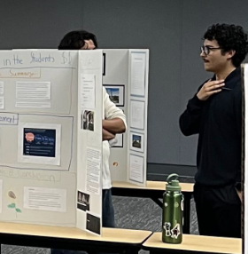
    - Appointments + resignation procedures
      - We need to organize a meeting for this
        - I’ll send out an email
    - Email announcements to send out:
      - Wrap up email for CoC
        - Introducing new chairs and contacts
        - Spring cleaning / how to update BCU legal code to add or remove positions
        - Anonymous CoC feedback form → what we can improve on next year
        - Final spreadsheet reminder
      - New execs! I’m drafting an email soon to send to each new exec about filling their offices / hiring
        - Emailed
      - LHP → needs assistance with creating emails + being added to the chairs list
        - I emailed them
      - Office of the Controller + COC hiring pub
        - IG →
        - Department emails →
        - Mass email →
      - General COC positions pub
        - Last AS newsletter submission due thursday → submitted
        - Need to update the website before that goes out →
      - LHP hiring pub
        - Can we get an IG post for this?
    - Gateway approved for energy drinks!
      - We need to decide a day for this event, either week 9 or 10 at this point → waiting for the final steps of the gateway to complete so i can get a shipping estimate from amazon
        - We can invite any other hiring orgs to table with us if they would like to

      - Updated the budget with that final amount
      - 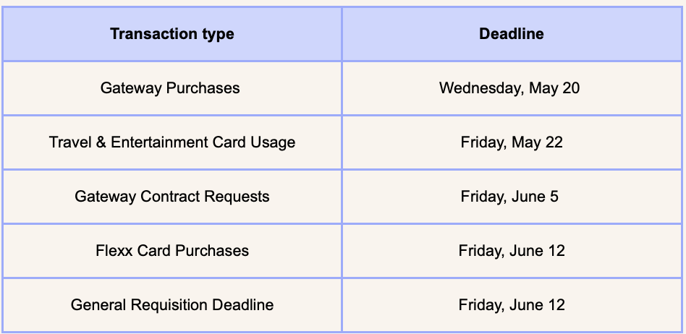
      - We would have ~$1,419.17 leftover, let’s pass some money for outreach materials + (??)
        - We can either do some BCU bonding at AS awards (fund some nothing bundt cakes??? Treat all of our wonderful BCUs or do another free food and applications event and flexcard → either way need to wrap things up by end of week 10
          - RSVP
            - New members welcome !!
    - Internal Chair Passdown Report

Shuyi Sum - External Chair
    - QOTW: Potlucks are great for bonding!
    - Sent out acceptance/rejection emails + updated CoC positions on the website
    - Note DATE/LOCATION changes for AS Awards - Thursday 06/04 5pm at The Club & Guest House
    - Got an email asking about CoC positions but they didn’t apply on the website after I responded - I could email again with the remaining open positions and encourage them to apply?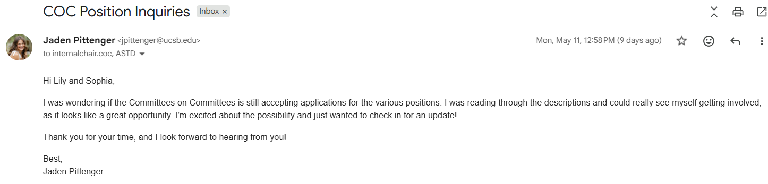
    - External Chair Overview of Duties
    - Vice Chair Overview of Duties
    - When2Meet for tabling

Oliver Ramirez Carrera - Vice Chair
    - QOTW: CoC is the best BCU
    - Hosted interview w/ Mira and Savanah for O&R
    - Completed overview of duties
    - Meeting w/ advisors on the 26th to promote CoC and the spreadsheet, to hopefully create a better foundation for communication within the Association
    - Got into contact w/ Yoyo over CoC design
    - Updated spreadsheet, sent out emails to chairs
    - Tasks:
      - Wrap up email for CoC
        - Introducing new chairs and contacts
        - Spring cleaning / how to update BCU legal code to add or remove positions
        - Anonymous CoC feedback form → what we can improve on next year
        - Final spreadsheet reminder
      - Send out email to chairs about tabling once we get a date sorted out
      - Check Lily’s text and do whatever she said
        - Whenever you get a chance can you link past chairs meeting slides, past state of the association slides, flex card / contact for chairs meeting food, maybe an example email you sent to announce the chairs meeting to your passdown
      - RSVP for A.S. Awards Banquet
      - When2Meet
      - Send out email to the Controller applicants
      - Get in touch for passdown reports!
        - W/ Kristin
      - https://www.when2meet.com/?36803661-u4Ibq

VACANT - Internal Liaison

Layla Hakim - Outreach and Recruitment Careers Coordinator
    - QOTW: restaurants are great for retreat ideas😋
    - Event ideas:
      - Tabling with finals survival kits
      - Study session - food and energy drinks?
      - Summer prep - food and planning how to stay productive over summer (include opportunities for AS)
      - Vision board making for next year
      - Study session and snack bar
      - Trivia (about UCSB + AS maybe) and some sort of prize like a large gift card to food in IV
      - Finals survival kit making
        - Gum, tea, candy, sticky notes, liquid iv, energy drink, snacks, notecards, fidgets, etc
    - Not many updates this week, made the fliers for the event
    - Careers Coordinator Transition Doc
    - I can send department emails for Office of the Controller + COC + LHP

Mira Ikladious - Outreach and Recruitment Media Coordinator
  - We are so fun!!
  - Didn't do much, just prep for my last 2 midterms next week
  - Hosted last fuel future event w oliver
  - Interviewed for O&R, seemed pretty good
  - Will add contacts and ect for passdown (new email for O&R)
  - Did my passdown report
  - Found all of Sophia’s reqs
  - Ill post on IG for CoC
  - And post for office of the office of the controller
  - ^ more open position on website
O&R passdown report

VACANT - Outreach and Recruitment DEI Coordinator

Savanah Lizet Aldaba - Outreach and Recruitment On-Campus Coordinator
    - QOTW- Our potlucks are goated.
    - Interviewed Charlie last week with Mira and Oliver
    - Event Ideas
      - We could do an activity like tye-dying tshirts or making key chains, but I feel like the safest bet to put money to good use is always free food!
    - Transition Report

Archish Prakhya - Pearman

Adam Orenstein - Commissioner of Community and Climate

C. Action Items

- ACCEPTANCE of AGENDA/CHANGES to AGENDA

- CONSENT ITEMS

- Approval of our Action Summary/Minutes from:

- ACTION ITEMS

F-1. Old Business:

F-2 New Business:

- DISCUSSION ITEMS

- Discussion Topic

- REMARKS

- ADJOURNMENT

MOTION/SECOND: Oliver/Mira
Motion Language: Motion to approve $500 for energy drinks to table in the arbor for a power up your resume event.
ACTION: CONSENT

MOTION/SECOND: Oliver/Shuyi
Motion Language: Motion to approve up to $600 for CoC stickers and outreach materials, fliers, plastic stands, etc.
ACTION: CONSENT

MOTION/SECOND: Oliver/Layla
Motion Language: Motion to approve up to $600 for a new custom CoC tablecloth.
ACTION: CONSENT

MOTION/SECOND: Mira/Oliver
Motion Language: Motion to adjourn this meeting at 5:33pm.
ACTION: CONSENT

